***Lyddie***

***Chapter 9 – The Weaving Room***

Lyddie hears huge rattles and clacks and bangs as she enters the [weaving](http://bookbuilder.cast.org/view_glossary.php?book=110490&word=85654#curr)  room for the first time.  There were shrieks and whistles and Lyddie couldn’t even clear her head.

Lyddie walked through the area amazed by how the girls didn’t even seem to be[phased](http://bookbuilder.cast.org/view_glossary.php?book=110490&word=85655#curr) by the machinery or the [deafening din](http://bookbuilder.cast.org/view_glossary.php?book=110490&word=85656#curr) of the looms.

Lyddie sees [shuttles](http://bookbuilder.cast.org/view_glossary.php?book=110490&word=85657#curr)  going back and forth holding the [weft thread](http://bookbuilder.cast.org/view_glossary.php?book=110490&word=85658#curr)  and realizes how quickly everything is moving.

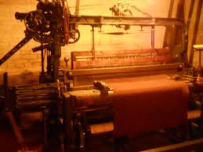

 Lyddie followed the [overseer](http://bookbuilder.cast.org/view_glossary.php?book=110490&word=85660#curr)  through the room and she could tell that he was talking but she couldn’t hear anything.  Then, the [overseer](http://bookbuilder.cast.org/view_glossary.php?book=110490&word=85659#curr)  leaned towards her and said “Is everything clear?”

Lyddie was so confused because nothing was clear to her! It was so loud in the room and everything was so dusty and she was so overwhelmed she had not heard a word he said. Lyddie knew she could not say she didn’t understand so instead she just stood there.

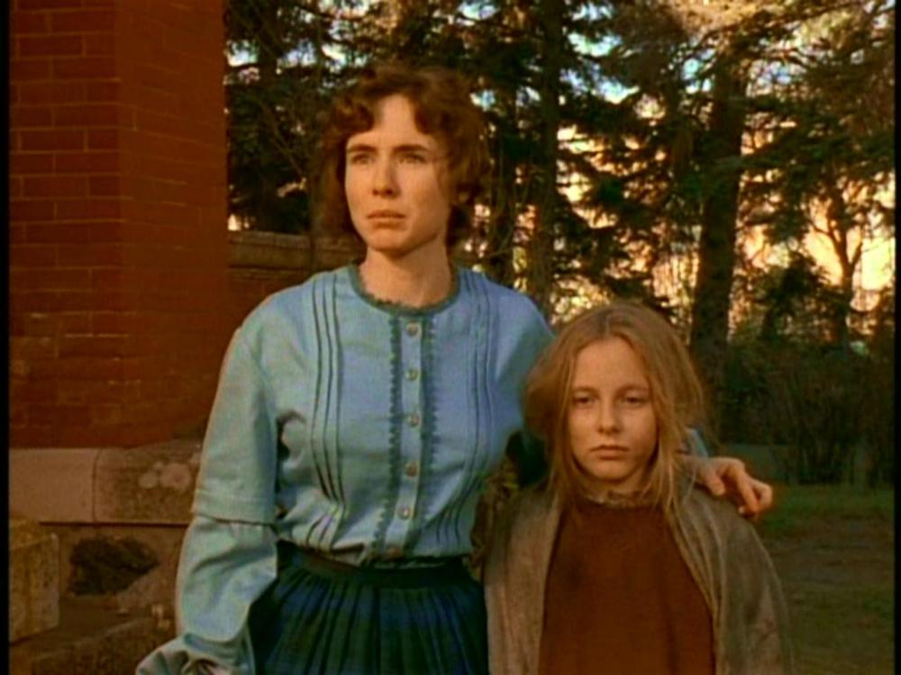

Soon, another young girl came over and said to the overseer “don’t worry Mr. Marsden, I’ll make sure she knows what to do and I’ll look after her”.  Mr. Marsden walked away and the girl said to Lyddie “don’t worry, we’ll work together”.  Then, the girl introduced herself as Diana.

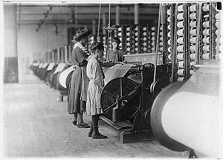

Lyddie watched while Diana showed her how to use the shuttles.  When one got to her, Diana put her mouth to it and sucked out the [weft thread.](http://bookbuilder.cast.org/view_glossary.php?book=110490&word=85661#curr)   Lyddie looked at Diana strangely when she did that and Diana told her “we call this the kiss of death!”

 Lyddie watched Diana for hours and helped when she could.  Diana showed her that if a thread breaks you have to find it quickly or you might get in trouble.  Lyddie finally tired to do some of the work herself but felt weak and uncomfortable even though on the farm she [prided](http://bookbuilder.cast.org/view_glossary.php?book=110490&word=85662#curr)  herself on being strong and capable.

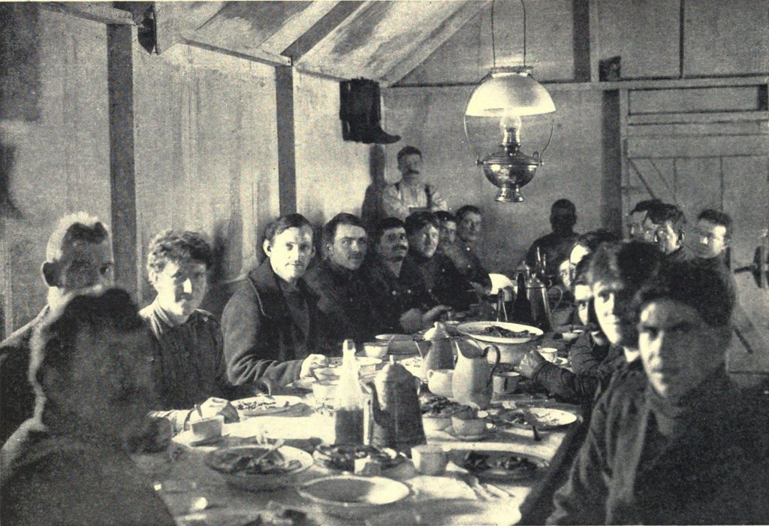

After the first long day of work, Lyddie told Diana that she was having trouble with the contract she had signed which had all the rules in it.  Diana told her to come over to her room later and she would help her look through it all.

While Lyddie is eating dinner the other girls, Prudence, Betsy, and Amelia, tell her that Diana Goss, her new friend, is someone she should stay away from.  Lyddie decides she doesn’t care and goes over to Diana’s anyway.  Diana tells her that the other girls don’t like her because of the people she hangs out with and the things they believe in.

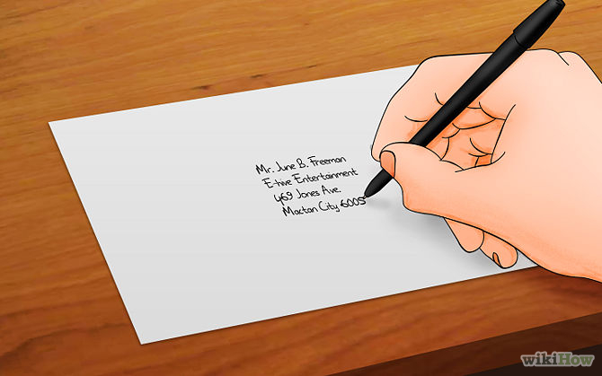

 Lyddie and Diana talk about their families and Lyddie learns that Diana really doesn’t even have a family.  As Lyddie talks about her family Diana realizes something is wrong.  Diana asks what it is and Lyddie tells her she is upset because she had not written to them in a long time.  Diana offers to give her the paper and postage to send a letter to Mama and to Charlie.  Lyddie is so grateful because she knows how expensive that is and promises to pay her back as soon as possible.



Lyddie’s letter to Mama says:

Dear Mother,

You will be surprized to no I am gone to Lowell to work.  I am in the weving rum at the Concord Corp. I bord at number 5 if you rit me.  Everwun is kind and the food is plenty and tasty.  I am saving my muny to pay the dets.  I am well.  I trus you and the babies are well.

-Lyddie.



Lyddie’s letter to Charlie says:

Dear Bruther,

Do not be surprize.  I am gone to Lowell for a factory girl.  Everywun is kind.  The work is alrite but masheens is noiy, beleev me.  The muny is good.  I will save and pay off the dets.  So we can stil hop (Ha ha)

-Lyddie

p.s

I am at Concord Corporation Number 5 if you can rit.  Excuse al mistakes. I am in grate hury.

Then, the curfew bell rang and Lyddie headed back to her room for bed.

In chapter 9, Lyddie goes to work for Mr. Marsden in the weaving room. He assigns Diana Goss, who has been at the factory for some time, to watch over her and teach her what she needs to know. The two girls become friends, and Diana teaches her how to read and write; she encourages Lyddie to write a letter to her mother and brother and offers to mail it for her.

Lyddie's roommates warn her that it's not a good idea to be friends with Diana because of her criticism of the working conditions at the factory. Lyddie sees only Diana's kindness, however, and continues to be her friend.